27/10/2025
Mechanical Hardware Identification
M3 x 10mm or 12mm Countersunk Nylon Screws
- M3 refers to the 3mm diameter of the threaded shaft, with a 10mm or 12mm measurement including the ‘countersunk’ head. Countersunk (CSK) refers to the tapered edges of the head, meaning that the screw will sit flush with the surface.
M3 Nylon Nuts
- M3 refers to the 3mm internal diameter of the threaded hole.
M3 Nylon Washer
- M3 refers to the 3mm internal diameter of the hole.
M2 Metal Full Nut
- M2 refers to the 2mm internal diameter of the threaded hole. ‘Full’ refers to the vertical height.
M3 Metal Nuts: Full & Lock
- M3 refers to the 3mm internal diameter of the threaded hole. ‘Full’ refers to the vertical height, whilst the locknut prevents unintentional loosening. The locknut can be recognised by the nylon lining inside the nut.
M3 x 6mm Countersunk Metal Screw
- M3 refers to the 3mm diameter of the threaded shaft with the 6mm measurement including the ‘countersunk’ head. Countersunk (CSK) refers to the tapered edges of the head meaning that the screw will sit flush with the surface.
M3 Metal Screws: 12mm Panhead & 25mm
- M3 refers to the 3mm diameter of the threaded shaft with the 12mm and 25mm measurements NOT including the head. Note the M3 x 12mm panhead may be the nylon material variant rather than metal.
Rear Chassis Spacer
- The colours of this 3D printed part may vary but the spacers are designed to accommodate M3 screws, so the internal hole has a diameter of approximately 3mm.

Surface Mount Components
I soldered on all the surface mount components. This included all the resistors, majority of the capacitors and 2 new components, the 5V regulator and the reverse protection MOFSET.






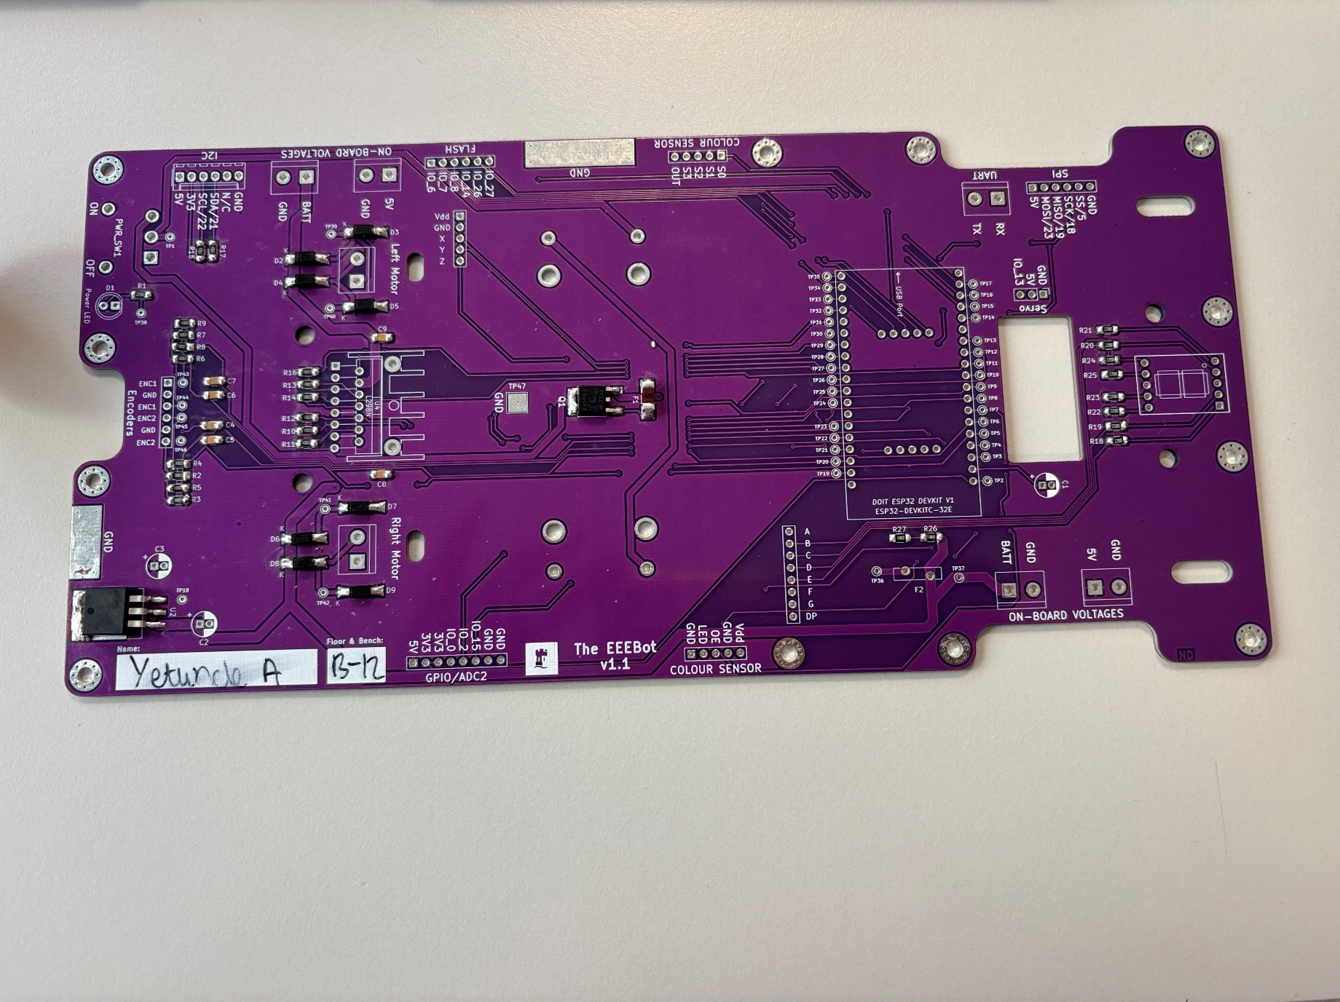
(Figure 1 SMD components on PCB)
5V regulator - Provides a stable output voltage of 5V regardless of changes in the input voltage or load conditions.
Reverse protection MOFSET – Protect electronic Circuits from damage caused by reverse current when the supply voltage is reversed. The MOFSET allows current to flow from the positive side of the supply towards the negative side.

Front Steering Chassis
I pushed the servo through the front chassis plate and used the two M2 x 6mm or 10mm metal panhead screws to secure the servo to the plate I put a M2 metal locking washer between each M2 nut and plate.
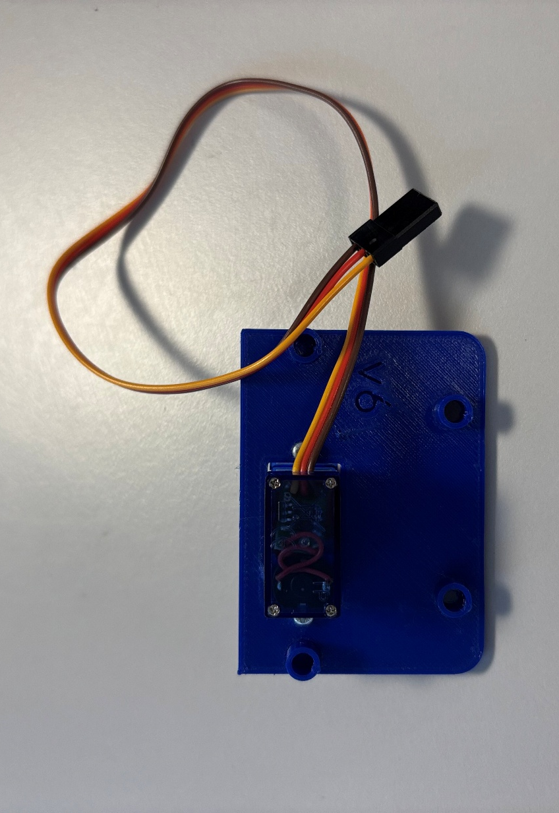
(Figure 2 Front Steering Chassis)

Front Steering Axle
I connected the wheels to the axle using the front axle spacer with grub scrub and secured this with an Allen key.
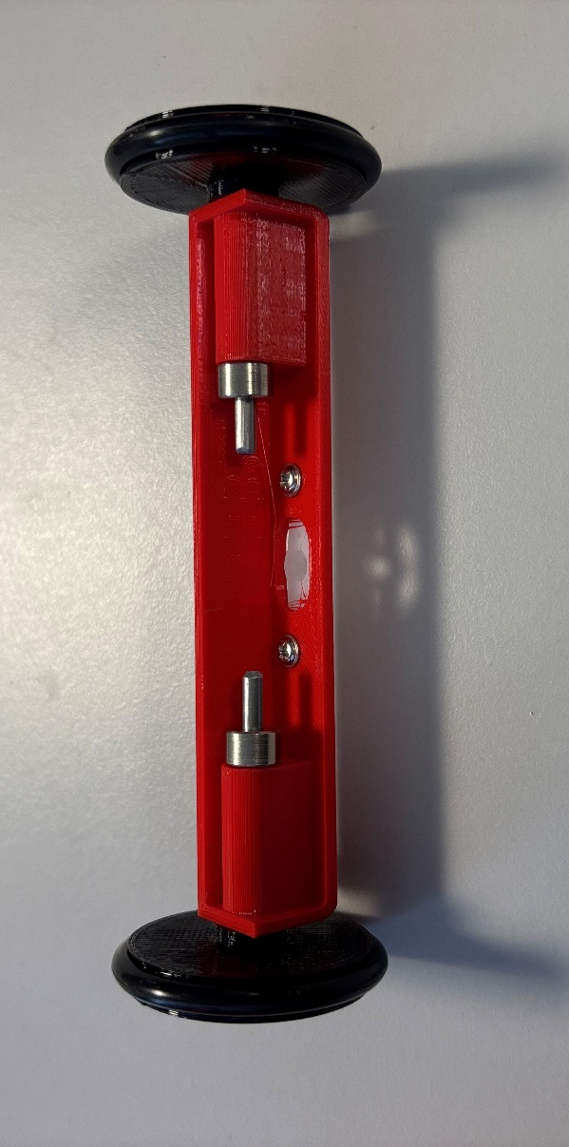
(Figure 3 Front Steering Axle with Wheels)

Through Hole Components
I soldered all the through hole components this includes, capacitors, an LED, headers, a pin head, a fuse, a power switch, a motor driver and head sink, a 3-way male header, a 6-way male MOLEX connector, and 2-way terminal blocks.

(Figure 4 Through Hole Components on PCB)
A motor driver and head sink, a 3-way male header, a 6-way male MOLEX connector, and 2-way terminal blocks.

